# ABSTRACT

The Smart IoT Feeder with RFID-Based Monitoring and Health Tracking system is designed to revolutionize pet care by integrating RFID technology, IoT capabilities, health monitoring features, and cloud storage. This innovative system aims to automate pet feeding while continuously tracking the health of pets. The RFID-based identification system ensures that the pet is properly recognized before being fed, providing a more personalized feeding experience. The core feature of this system is its ability to monitor the pet's health condition using an ultrasonic sensor embedded in the pet’s feeding bowl. The ultrasonic sensor measures the depth of the food in the bowl. If the food level is consistently high, it indicates that the pet is consuming food regularly, signaling normal health conditions. Conversely, if the food level remains lower than usual, it suggests that the pet may be facing health issues, such as a loss of appetite, indicating the need for further attention or a veterinary check-up.This IoT-enabled system provides real-time alerts, ensuring that pet owners are promptly informed of any irregularities. All the data related to feeding activity and health status is stored securely in the cloud, allowing pet owners to access and monitor their pet's data from anywhere, at any time, using a connected device. The integration of RFID, IoT, ultrasonic sensors, and cloud technology offers a comprehensive solution for enhancing pet care, making it easier to monitor both feeding habits and health conditions, ultimately improving the overall well-being of pets.

# TABLE OF CONTENTS

ACKNOWLEDGEMENT ii

APPROVAL AND DECLARATION iv

ABSTRACT 5

TABLE OF CONTENTS viii

LIST OF FIGURES x

CHAPTER 1 1

1.1 Overview 1

1.2 Applications 1

CHAPTER 2 2

2.1 Technical Background 2

2.1 Related Works 4

2.1.2 Inference from the Literature Review 5

CHAPTER 3 8

3.1 Problem Statement 8

3.2 Objectives 8

3.3 Methodology 9

3.4 Advantages 10

3.5 Scope of the Project 10

3.6 Hardware 11

3.6.1 Arduino Uno 11

3.6.2 RFID Module 12

3.6.3 Ultrasonic sensor 13

3.6.4 16X2 LCD Display 14

3.6.5 I2C Module 15

3.6.6 Breadboard 16

3.6.7 Servo motor -SG90 17

3.6.8 Jumper wires 18

3.6.9 Food dispenser 19

3.6.10 IR Sensor 20

3.7 Block diagram 20

3.8 Flow Chart 22

CHAPTER 4 23

RESULTS AND DISCUSSION 23

CHAPTER 5 25

CONCLUSION 25

REFERENCES 26

# LIST OF FIGURES

3.6.1 Arduino Uno 11

3.6.2 RFID Module 12

3.6.3 Ultrasonic sensor 13

3.6.4 16X2 LCD Display 14

3.6.5 I2C Module 15

3.6.6 Breadboard 16

3.6.7 Servo motor -SG90 17

3.6.8 Jumper wires 18

3.6.9 Food dispenser 19

3.6.10 IR Sensor 20

3.7 Block Diagram of IoT based Pet feeder 22

3.8 Flow Chart 23

4.1 Working Hardware Model 25

4.2 Cloud Based Data Sheet 25

# CHAPTER 1

**INTRODUCTION**

The Smart iot Feeder with RFID-Based Monitoring and Health Tracking is an advanced pet care solution that combines automation, health monitoring, and real-time data analytics. Unlike traditional feeding methods, this system uses iot technology, RFID, and ultrasonic sensors to ensure pets are fed accurately and health is monitored. The RFID system identifies each pet, ensuring they receive the correct amount of food at the right time, while the ultrasonic sensor tracks food levels in the bowl to detect potential health issues, such as loss of appetite. If food consumption is low, it signals a health concern.

All data is securely stored in the cloud, allowing pet owners to remotely monitor feeding habits and health status, offering continuous tracking and easy access to historical data. This system improves pet care by ensuring proper feeding and providing valuable health insights, making it a reliable and efficient solution for modern pet owners.

## Overview

The Smart IoT Feeder with RFID-Based Monitoring and Health Tracking automates pet feeding and monitors health using RFID technology, IoT, and ultrasonic sensors. Each pet is identified by a unique RFID tag, ensuring they are fed according to their schedule. The ultrasonic sensor tracks food levels in the bowl, indicating the pet’s health—low food levels may signal issues like decreased appetite. All data is stored securely in the cloud, allowing pet owners to remotely monitor their pet’s activity via a camera, providing a convenient and secure way to track their pet’s well-being.

## Applications

* **Pet Health Monitoring**: The ultrasonic sensor detects changes in food level to monitor pet health; unusually high food levels may indicate issues like loss of appetite.
* **Automated Feeding System**: The RFID system ensures only the correct pet is fed, preventing food theft and automating feeding to reduce manual effort.
* **Remote Monitoring & Cloud Access**: Owners can monitor feeding activity and receive alerts via IoT apps, with all data securely stored in the cloud for remote access and continuous monitoring.

# CHAPTER 2

**LITERATURE REVIEW**

## Technical Background

The development of smart IoT-based pet feeders represents a significant technological advancement in automated pet care. This evolution has been driven by the convergence of automation, wireless communication, embedded systems, and sensor integration. Traditional pet feeders, which required manual refilling and scheduling, have transformed into intelligent, data-driven devices capable of responding dynamically to pets' needs. These modern systems allow for remote access, real-time monitoring, and automated feeding schedules, even in the absence of pet owners.

Several research studies have shown that IoT-enabled pet feeders substantially enhance pet care management. By leveraging cloud connectivity and mobile applications, these systems provide pet owners with the ability to monitor and control the feeding process from virtually anywhere. Features such as automated alerts, customizable feeding intervals, and data visualization improve the consistency and quality of pet nutrition, which is particularly useful for households with busy schedules or multiple pets.

* **RFID Technology for Personalized Pet Identification**

A cornerstone of smart feeder systems is the use of Radio Frequency Identification (RFID) technology to enable personalized feeding. Each pet wears a collar with a unique RFID tag, which contains an identification code. When a pet approaches the feeder, the embedded RFID reader detects and authenticates the tag. Upon verification, the system dispenses food tailored for that specific pet.

RFID-based pet identification ensures that feeding is exclusive and accurate, minimizing the risk of food theft between pets or overfeeding. Research highlights the effectiveness of RFID systems in multi-pet environments, where dietary requirements and feeding schedules may vary. RFID technology also facilitates the maintenance of individualized feeding logs, providing valuable insights into each pet’s dietary habits and overall health trends.

* **Non-Invasive Health Monitoring through Food Intake Analysis**

Another significant advancement in smart pet feeder systems is the ability to monitor a pet’s health through consumption behavior. A sudden decline in food intake often serves as an early warning sign of underlying health problems, such as infections, digestive issues, dental pain, or psychological stress. Smart feeders equipped with consumption-tracking features can analyze eating patterns and detect these anomalies.Instead of relying on physical contact or invasive procedures, the system uses consumption data to non-invasively assess pet health. If a pet repeatedly fails to consume its food or displays irregular feeding patterns, the system can automatically notify the owner through an IoT-based alert mechanism. This proactive approach helps in identifying issues early and allows timely medical intervention, potentially reducing veterinary costs and improving the pet’s quality of life.

* **Ultrasonic Sensing for Food Level Detection**

To accurately measure food intake, the system employs an ultrasonic sensor mounted above the food bowl. This sensor emits ultrasonic waves and calculates the distance based on the time it takes for the waves to reflect back from the surface of the food. By continuously monitoring this distance before and after feeding sessions, the system can determine the quantity of food consumed.

If the sensor detects that the food level remains consistently high over a series of feeding cycles, it implies that the pet may not be eating as expected—an indication of possible health concerns. Ultrasonic sensors are particularly well-suited for this task due to their non-contact operation, high reliability, and low maintenance requirements.

By integrating RFID-based monitoring with ultrasonic-based health tracking, this smart feeder project creates a comprehensive and intelligent pet care solution. The system not only ensures that feeding is secure and tailored to individual pets but also offers an early warning system for potential health issues. Through automation, real-time communication, and behavior analysis, the Smart IoT Pet Feeder significantly enhances both the efficiency and quality of pet care, making it a valuable tool for modern pet owners.

## Related Works

The integration of IoT technologies in pet care systems has gained significant attention in recent years. Researchers have developed various automated pet feeder systems aimed at enhancing pet well-being and reducing the dependency on constant human supervision. Most systems incorporate microcontrollers such as Arduino or Raspberry Pi to manage sensor data, automate feeding schedules, and support wireless connectivity.

In 2018, R. Sharma et al. developed an IoT-enabled pet feeder using NodeMCU and cloud integration, allowing users to remotely dispense food through a mobile app. Their system improved feeding consistency and reduced overfeeding. However, it lacked individualized monitoring and health analysis capabilities.

To address pet-specific identification, A. Desai and S. Patel (2019) implemented RFID-based smart feeders that recognized pets by their RFID tags. The system ensured that each pet received its designated food, which was especially useful in multi-pet households. This research highlighted the effectiveness of RFID technology in improving feeding precision, but it did not include any health monitoring features.

In 2020, K. Banerjee et al. proposed a smart feeder with a weight sensor placed under the bowl to track food intake. Their approach identified changes in eating habits over time to detect potential health problems. Although the concept was practical, weight sensors increased system cost and required physical contact with the food bowl, leading to maintenance issues.

Recent studies have turned to ultrasonic sensors for non-contact monitoring. In 2021, L. Kim et al. demonstrated the use of ultrasonic sensors for water level detection in animal care systems, noting their accuracy and ease of integration. Inspired by this, our project applies the same principle for dry food level detection, using the ultrasonic sensor to determine if the pet is eating regularly.

Combining RFID-based pet identification with ultrasonic-based food level monitoring, our system offers a dual-function solution that ensures correct feeding while indirectly monitoring pet health. This approach represents a significant advancement over prior work by providing individualized feeding and early health issue detection in a cost-effective and scalable manner.

### Inference from the Literature Review

Based on an in-depth review of existing literature and prior developments in the fields of IoT, pet health monitoring, and automated feeding systems, several key insights have been identified that significantly shape the design and implementation of the proposed Smart IoT Pet Feeder. These insights validate the integration of emerging technologies and provide a foundation for building a reliable, intelligent, and practical solution for modern pet care.

1. **IoT Integration for Remote Access and Automation**

The increasing adoption of **Internet of Things (IoT)** technologies in smart home applications has opened up new possibilities in pet care automation. Studies have consistently shown that IoT-enabled devices improve convenience and control by offering **remote access, real-time data synchronization,** and **automated scheduling.** In the context of pet feeding, IoT platforms allow owners to monitor and control feeding activities from anywhere using a mobile app or web interface. This is particularly useful for working professionals or frequent travelers who are unable to be physically present during feeding times.

Research also highlights the role of **data analytics** within IoT systems. Data collected over time can be processed to generate insights, such as changes in feeding habits or food consumption trends. The ability to **receive instant alerts** in response to abnormal behavior patterns, such as missed meals or irregular eating, makes the IoT component essential for maintaining the pet’s health and well-being. This real-time interactivity ensures that owners stay informed and can intervene early in case of problems.

2. **RFID Technology for Individual Pet Identification**

**Radio Frequency Identification (RFID)** technology has become a standard for identification and access control in many smart systems. In the realm of pet care, literature suggests that RFID-based systems are effective in managing multiple pets by ensuring **individualized access** to shared resources such as food bowls. By equipping each pet with a unique RFID tag, the feeder system can automatically recognize the animal and determine whether it is the correct time for feeding.

The advantage of RFID technology is its **non-intrusive and automated operation.** It does not require direct contact or user input, thereby minimizing human error and ensuring consistent system behavior. RFID-enabled feeders also help maintain **separate dietary schedules,** which is particularly important in households where pets have different age groups, nutritional needs, or medical conditions. Moreover, the use of RFID helps **record data per individual pet,** making long-term behavioral analysis more accurate and meaningful.

3. **Ultrasonic Sensors for Non-Invasive Health Tracking**

Another key insight from the literature is the use of **ultrasonic sensing** for measuring food depth and consumption. This method is preferred over physical weighing due to its **non-invasive nature**, ease of maintenance, and low power consumption. The ultrasonic sensor continuously monitors the level of food in the bowl before and after feeding sessions, providing a reliable indicator of how much food has been consumed.

Research suggests that monitoring food consumption is one of the most **practical methods for early health detection** in animals. A decrease in appetite or abrupt changes in consumption patterns can signal the onset of health issues such as gastrointestinal problems, infections, stress, or behavioral changes. The ability to track this data over time and identify trends is crucial for **preventive healthcare**, enabling owners to act before minor symptoms escalate into serious problems.

4. **Data Logging and Cloud Integration for Comprehensive Monitoring**

Modern smart systems benefit significantly from cloud integration, which allows for **centralized data storage, access, and analysis**. The literature supports the use of cloud-based platforms for recording historical data, feeding schedules, and behavioral logs. These records not only help pet owners monitor the current status but also provide valuable information for veterinarians during health assessments.

By logging pet-specific data, the system can generate **visual reports** such as graphs and timelines, which help in identifying anomalies or long-term behavior shifts. This feature is particularly useful for aged pets or those undergoing treatment, where feeding habits may directly correlate with recovery or decline

5. **Scalability and Cost-Effectiveness**

Finally, studies underline the importance of **cost-effective and scalable solutions** in smart pet care systems. The proposed integration of affordable components such as RFID modules, ultrasonic sensors, and microcontrollers like Arduino and ESP8266 ensures that the system remains accessible to a wide range of users. Scalability is another strength—new features like weight sensors, cameras, or temperature monitoring modules can be integrated without major system redesigns.

This modular and extensible design aligns well with the trends observed in literature, where user-friendly, customizable, and low-maintenance solutions are increasingly in demand. The combination of **RFID for personalization, ultrasonic sensing for health tracking,** and **IoT for remote control and alerts** delivers a comprehensive yet practical solution for contemporary pet care needs.

# CHAPTER 3

**PROPOSED METHODOLOGY**

## 3.1 Problem Statement

In today's fast-paced world, pet owners often struggle to consistently monitor their pets' feeding habits and overall health. To address this challenge, our project proposes a Smart IoT Pet Feeder with RFID-Based Monitoring and Health Tracking. The system uses RFID technology to identify individual pets and track their specific feeding schedules. An ultrasonic sensor is integrated into the feeding bowl to measure the depth of food. If the food depth remains high over time, it indicates reduced consumption, suggesting potential health issues. This system not only automates feeding but also provides early health alerts, enabling pet owners to take timely action. The solution aims to enhance pet care with remote monitoring, reliability, and early health detection.

## 3.2 Objectives

* The main objective of our project, Smart IoT Pet Feeder with RFID-Based Monitoring and Health Tracking, is to automate and enhance pet care using advanced technologies. The system uses RFID to uniquely identify individual pets and ensure that each receives the correct amount of food according to a personalized schedule. An ultrasonic sensor is integrated into the pet feeding bowl to monitor food depth, which serves as an indicator of the pet’s health condition.
* If the food depth remains high, it suggests that the pet has reduced its intake, indicating potential health issues. If the depth decreases as expected, the pet is considered to be in normal health. This system enables pet owners to remotely monitor feeding behavior and health status, ensuring timely intervention when problems arise. The aim is to provide a reliable, non-invasive, and smart solution for modern pet care.

## 

## 3.3 Methodology

The proposed project, Smart IoT Pet Feeder with RFID-Based Monitoring and Health Tracking, aims to streamline and enhance pet care by automating the feeding process and monitoring pet health in a seamless, intelligent, and real-time manner. This innovative solution is designed to address common challenges faced by pet owners, such as inconsistent feeding schedules, difficulty in tracking food intake, and the inability to detect early signs of health problems.

The system operates by first supplying power to activate all integrated components. A key element of the design is the RFID reader, which is embedded in the feeder. Each pet wears an RFID tag on its collar, containing a unique identification code. When a pet approaches the feeder, the RFID reader scans the tag and verifies the pet’s identity. If the pet is authorized and feeding is scheduled, the system grants access by dispensing food through a controlled mechanism, such as a servo-driven gate or rotating dispenser. This allows for individualized and secure feeding, preventing other pets from consuming food that is not meant for them.

The project also incorporates a health tracking mechanism using an ultrasonic sensor placed above the food bowl. This sensor continuously measures the depth of food before and after a feeding session. A consistent decrease in food level indicates that the pet has eaten properly, while minimal or no change in food depth over time may suggest reduced appetite or refusal to eat. Such behavioral changes can be early signs of underlying health issues, such as infections, stress, digestive disorders, or dental problems.

All feeding data, including pet identification, timestamps, and consumption levels, is recorded and sent in real time to an IoT platform via a microcontroller like Arduino UNO paired with a Wi-Fi module such as ESP8266. This enables remote monitoring through a mobile or web application, giving pet owners instant access to their pet’s feeding history, current status, and potential alerts. If abnormal behavior is detected—such as repeated missed meals—the system can send automated notifications to the owner, prompting timely intervention.

In addition to real-time alerts, the system maintains a cloud-based database of each pet’s feeding history. This allows for long-term tracking and trend analysis, helping both pet owners and veterinarians make informed decisions regarding diet adjustments and health evaluations. The data can also be visualized using graphs or summaries, offering insights into patterns that might otherwise go unnoticed.

The Smart IoT Pet Feeder is designed to be cost-effective, non-invasive, and easy to use. It utilizes widely available components and features a simple interface suitable for users with minimal technical background. Its modular structure allows for future upgrades, such as integration with cameras for visual monitoring or additional sensors for environmental data.

## 3.4 Advantages

* Highly Reliable
* Highly Secure
* Fast Processing Speed
* Economical Biometric Technology
* Low Memory Usage
* Easy to Use and User-Friendly

## 3.5 Scope of the Project

The scope of this project is to design and develop a Smart IoT Pet Feeder integrated with RFID-based monitoring and health tracking features. This system is intended to address the challenges faced by pet owners in maintaining consistent and healthy feeding routines, especially when managing multiple pets or a busy lifestyle. By combining automation, identification technology, and real-time monitoring, the Smart IoT Pet Feeder will provide a reliable, efficient, and intelligent solution for personalized pet care.

At the core of the system is RFID technology, which enables the feeder to identify individual pets based on the unique RFID tags they wear. Each time a pet approaches the feeding station, the RFID reader scans the tag and determines whether the pet is scheduled to be fed. This ensures that each pet receives the correct amount of food at the right time, reducing the risk of overfeeding or underfeeding. It also prevents unauthorized pets from accessing food meant for others, which is especially useful in multi-pet households.

To monitor food consumption, an ultrasonic sensor is employed to measure the depth of food in the bowl before and after feeding. By comparing the difference in food levels, the system can estimate how much food a pet has consumed during each visit. This data is crucial for tracking the pet’s eating behavior over time. Irregularities in food intake—such as a sudden drop in consumption—can be early indicators of potential health issues. When such anomalies are detected, the system will generate alerts for the owner, prompting timely attention and possible veterinary care.

The feeder is connected to an IoT platform, allowing real-time data transmission and remote monitoring. Pet owners can access a user-friendly interface via a smartphone or web application to view feeding logs, receive health alerts, and configure schedules. This feature is particularly beneficial for pet owners who are frequently away from home, as it ensures they remain informed and in control of their pet’s diet and health at all times.

This project also emphasizes cost-effectiveness and ease of use. The hardware components—including the RFID module, ultrasonic sensor, microcontroller (such as Arduino UNO), and IoT module (like ESP8266)—are widely available and affordable. The system is designed with simplicity in mind, ensuring that even non-technical users can install and operate it with minimal effort.

In conclusion, the Smart IoT Pet Feeder with RFID-based monitoring and health tracking aims to revolutionize pet care by automating feeding routines, personalizing nutrition, and proactively identifying health issues. It enhances the bond between owners and their pets by ensuring better care with minimal manual intervention. This solution not only improves the quality of life for pets but also brings peace of mind to their owners, making it a practical and innovative advancement in the domain of smart pet technologies.

## Hardware

### 3.6.1 Arduino Uno

The Arduino Uno is a microcontroller board based on the ATmega328 (datasheet ). It has 14 digital input/output pins (of which 6 can be used as PWM outputs), 6 analog inputs, a 16 MHz ceramic resonator, a USB connection, a power jack, an ICSP header, and a reset button. It contains everything needed to support the microcontroller; simply connect it to a computer with a USB cable or power it with a AC-to-DC adapter or battery to get started.

The clock speed is 16 MHz, which translates to about executing about 300,00 0 lines of C source code per second. The board has 14 digital I/O pins and 6 analog input pins. There is a USB connector for talking to the host computer and a DC power jack for connecting an external 6-20 V power source, for example a 9 V battery, when running a program while not connected to the host computer. Headers are provided for interfacing to the I/O pins using

22 g solid wire or header connector

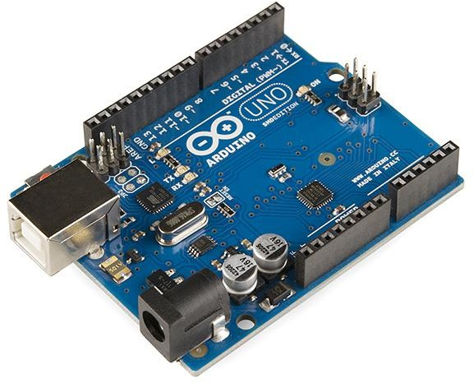 **Figure 3.6.1: Ardiuno Uno**

### 3.6.2 RFID Module

The RFID-RC522 Reader is a popular and cost-effective module used for reading RFID tags, making it ideal for applications like your Smart IoT Pet Feeder with RFID-Based Monitoring and Health Tracking system. This reader can interface with a variety of RFID tags, including MFRC522-compatible transponders. It communicates with the Arduino via the SPI interface and provides an efficient and reliable way to uniquely identify pets based on their RFID tags.

The RFID tags are passive transponders that contain unique identification information. When a pet's tag comes within the proximity of the RC522 reader, the reader scans the tag and sends the unique tag identification number to the Arduino, which processes this data to determine whether the pet is authorized to feed. The system also tracks pet feeding behaviors based on this identification data, assisting in health monitoring.

**Product Features:**

* Low Power Consumption: Typically operates at 3.3V, making it suitable for low-power devices.
* Reading Range: 2-5 cm depending on the tag and environment.
* Fast Communication: Uses SPI interface for fast and reliable data transfer.
* Easy to Interface: Directly connects to microcontrollers like Arduino with minimal wiring.
* Compact Design: Small and lightweight, ideal for integrating into the feeder system.
* Status LED: Provides visual feedback when a tag is detected, improving system visibility.

**Key Specifications:**

* Power Supply: 3.3V-5V DC
* Current Consumption: < 50mA
* Frequency: 13.56 MHz
* Communication: SPI Interface
* Dimensions: 40mm x 60mm x 10mm
* Operating Temperature: -20°C to +85°C

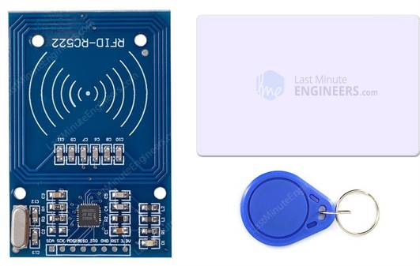

**Figure 3.6.2: EM-18 RFID Reader**

### 3.6.3 Ultrasonic sensor

HC-SR04 Ultrasonic Sensor is a widely used distance measuring module that utilizes ultrasonic waves to calculate the distance between the sensor and the target. The sensor consists of two main components: the transmitter and the receiver. It sends out an ultrasonic pulse, which bounces off the target and returns to the sensor, where the distance is calculated based on the time it takes for the pulse to return.

**Features:**

* Accurate Distance Measurement: Can measure distances ranging from 2 cm to 400 cm with an accuracy of up to 3 mm.
* Low Power Consumption: Consumes very low power, making it suitable for battery-powered applications.
* Simple Integration: Easily integrates with microcontrollers like Arduino, Raspberry Pi, and other embedded systems.
* Cost-Effective: Inexpensive and widely available for use in various applications, including robotics, automation, and pet monitoring systems.
* High-Frequency Response: Sends and receives ultrasonic pulses at 40 kHz frequency for distance measurement.
* Non-contact Measurement: Provides non-contact measurement, making it ideal for scenarios where physical contact is not desired.

**Specifications:**

* Operating Voltage: DC 5V
* Current Consumption: 15mA (typical)
* Measuring Range: 2 cm to 400 cm
* Accuracy: 3 mm
* Frequency: 40 kHz ultrasonic sound waves
* 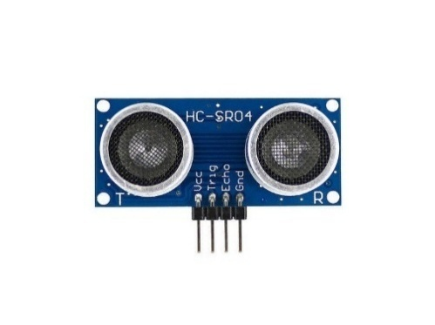Output: Digital pulse output

**Figure 3.6.3: Ultrasonic sensor**

### 3.6.4 16X2 LCD Display

LCD (Liquid Crystal Display) screen is an electronic display module and finds a wide range of applications. A 16x2 LCD display is a very basic module and is very commonly used in various devices and circuits. These modules are preferred over seven segments and other multi segment LEDs .

**Hardware Required:**

* + Arduino Board
  + 16x2 LCD Screen (compatible with the Hitachi HD44780 driver)
  + 10k ohm potentiometer
  + 220 ohm resistor
  + Hook-up wires
  + Breadboard

**Wiring the LCD Screen:**

* + Solder a pin header strip to the 14 (or 16) pin count connector of the LCD screen.
  + Connect the following pins between the LCD screen and your Arduino board:
    - LCD RS pin to digital pin 12
    - LCD Enable pin to digital pin 11
    - LCD D4 pin to digital pin 5
    - LCD D5 pin to digital pin 4
    - LCD D6 pin to digital pin 3
    - LCD D7 pin to digital pin 2

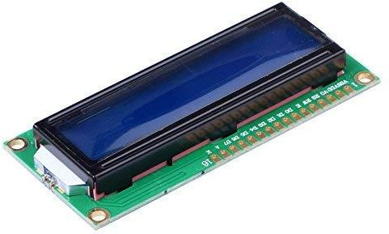

**Figure 3.6.4: LCD Display 16x2**

**Liquid Crystal Library:**

* The Liquid Crystal library simplifies controlling LCD displays compatible with the Hitachi HD44780 driver.
* You can use either 4-bit mode (requires 7 I/O pins) or 8-bit mode (requires 11 pins).
* For displaying text, 4-bit mode is sufficient.

**I2C Interface Option:**

* + If you prefer a simpler connection, consider using a 16x2 I2C LCD display.
  + These displays come with an I2C interface, which reduces the number of required pins.

### 3.6.5 I2C Module

The I2C module is a communication protocol that allows multiple devices to communicate with each other using a master-slave architecture. It uses two wires:

1. SDA (Serial Data): This wire carries the actual data between devices.
2. SCL (Serial Clock): This wire synchronizes the data transmission.

The I2C module is commonly used for connecting various components in embedded systems, such as sensors, displays, EEPROMs, and other peripherals. It simplifies communication by allowing multiple devices to share the same bus, reducing the

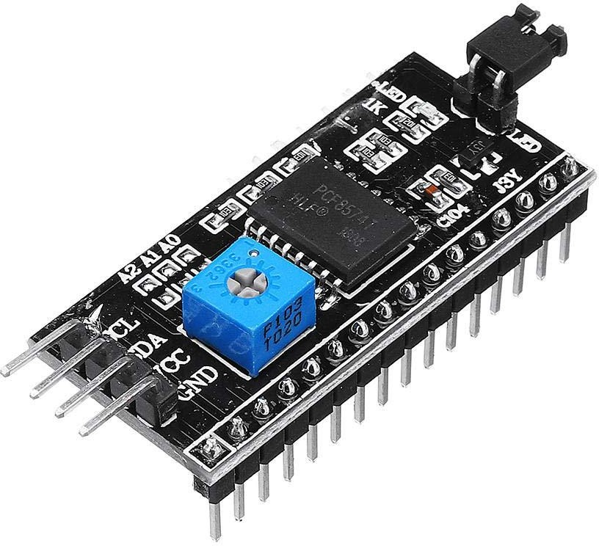number of required pins on microcontrollers or microprocessors. One specific example of an I2C module is the I2C Serial Interface Adapter Module.

**Figure 3.6.5: I2C Module**

**Features:**

* Operating Voltage: 5V DC
* Control Chip: PCF8574
* Maximum Modules on a Single I2C Bus: 8
* I2C Address Range: 0x20 to 0x27 (you can change it via onboard jumper pins)
* Pin Configuration:
* GND: Ground
* VCC: Voltage Input (5V)
* SDA: Serial Data (I2C)
* SCL: Serial Clock (I2C)backlight

### 3.6.6 Breadboard

A breadboard serves as a versatile platform for prototyping and testing electronic circuits, making it an essential tool for the development of the Smart IoT Pet Feeder with RFID-Based Monitoring and Health Tracking system. It allows you to easily connect and test components such as the RFID reader, ultrasonic sensor, Arduino microcontroller, and other circuit elements without the need for soldering.

In the context of this project:

* The Arduino microcontroller is placed on the breadboard to interface with various components like the RFID module, ultrasonic sensor, and IoT communication module.
* The RFID reader will be connected to the breadboard to scan pet tags and ensure that only authorized pets are fed.
* The ultrasonic sensor is used to detect food depth, which will help assess the pet's health based on consumption patterns.
* The breadboard ensures that all components are connected in a secure and flexible manner, making it easy to modify connections and test different configurations during development.
* 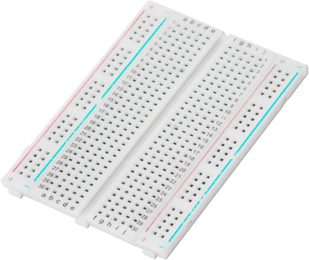This breadboard setup is particularly beneficial for iterative testing, allowing for quick adjustments and real-time debugging before finalizing the design on a PCB (Printed Circuit. Board).

**Figure 3.6.6: Bread board**

### 3.6.7 Servo motor -SG90

SG90 Servo Motor is a small and efficient motor commonly used in various robotic and automation applications, including your Smart IoT Pet Feeder with RFID-Based Monitoring and Health Tracking project. The motor is designed for precise control over angular positioning, making it ideal for tasks such as moving the pet food dispenser or lid.

Working Principle: The SG90 operates by receiving Pulse Width Modulation (PWM) signals from the microcontroller. The motor's shaft rotates to specific angles based on the PWM signal, enabling accurate positioning within a 180-degree range. This feature is crucial for tasks that require controlled, repetitive movements.

**Applications:**

* Pet feeder lid or compartment control
* Robotics and automation systems
* Precision-controlled movements in small devices

**Key Specifications:**

* **Operating Voltage:** 4.8V to 6V DC
* **Torque:** 1.2 kg/cm (at 5V)
* **Rotation Range:** 180 degrees
* **Speed:** 0.1s per 60 degrees at 5V
* **Size:** 22.2mm x 11.8mm x 22.6mm
* **Weight:** 9g

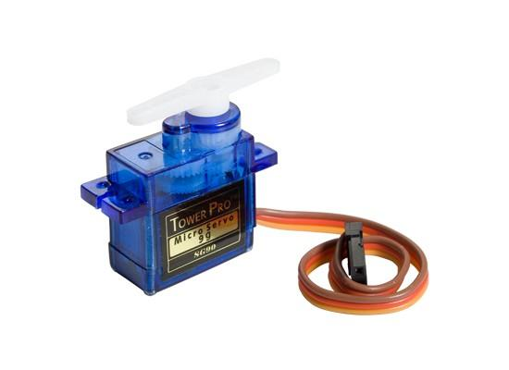

**Figure 3.6.7: Servo Motor**

### 3.6.8 Jumper wires

Jumper wires are essential components for connecting electronic components on a breadboard or other prototyping platforms. Let’s explore the different types:

* 1. Male to Male Jumper Wires:
* These wires have male pins on both ends.
* The male ends fit into standard 0.1-inch (2.54mm) female sockets.
* Length: Typically around 20cm (8 inches).
  1. Female to Female Jumper Wires:
* These wires have female pins on both ends.
* They are useful for connecting female headers or components with female pins.
* Length: Similar to male-to-male wires (around 20cm).
  1. Male to Female Jumper Wires:
* These wires have a male pin on one end and a female pin on the other.
* They allow you to connect male headers to female sockets.
* Length: Typically around 20cm.

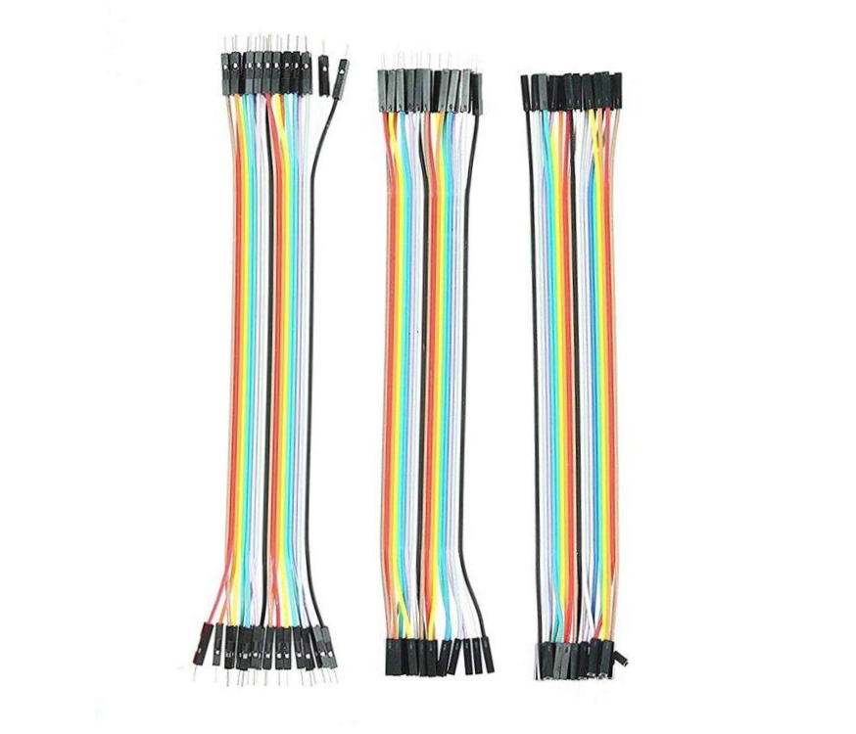

**Figure 3.6.8: Jumper wires**

### 3.6.9 Food dispenser

A food dispenser in a Smart IoT Feeder precisely allocates food portions based on preset schedules. It operates with high accuracy to avoid overfeeding or wastage. Integrated with RFID technology, it identifies individual animals to dispense customized meals. The dispenser ensures consistent food flow, prevents clogs, and provides data on food consumption for monitoring and health tracking.

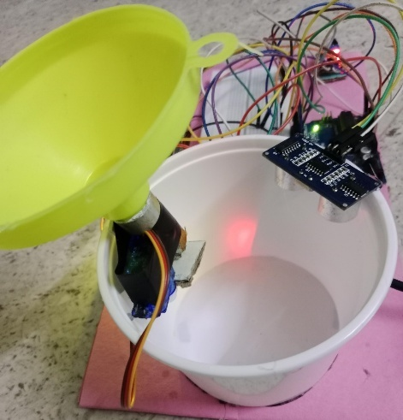

**Figure 3.6.9: Food Dispenser**

### 

### 3.6.10 IR Sensor

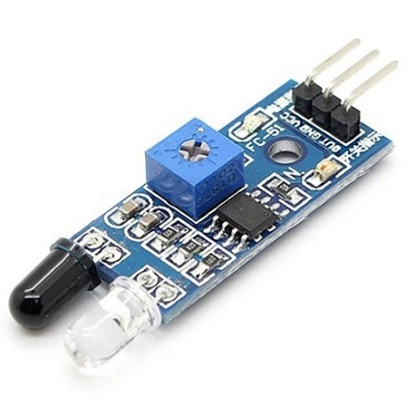In this Smart Pet Feeder project, the IR sensor plays a crucial role in detecting the presence of the pet near the feeding station. It works by sensing obstacles (in this case, the pet) based on the reflection of infrared light. When no pet is nearby, the IR sensor outputs a HIGH signal, indicating that the area is clear. When a pet approaches, the sensor output changes to LOW, signaling that an object (the pet) is detected. This change triggers the system to prompt for an RFID card scan to identify the pet. Using the IR sensor helps the feeder to operate intelligently by only activating the RFID reader when a pet is present, saving power and reducing unnecessary scanning. It also helps in updating the LCD screen to show real-time status, such as "Obstacle Detected" or "Waiting for RFID." Additionally, once the pet leaves, the IR sensor detects the absence again and measures the remaining food depth using the ultrasonic sensor. Thus, the IR sensor ensures that the system remains responsive, efficient, and smart in detecting and serving the correct pet.

**Figure 3.6.10: IR Sensor**

## 3.7 Block diagram

The block diagram of a fingerprint-based car ignition system, can be described as an integration of several key components that work together to provide secure vehicle access and ignition through biometric authentication. The primary components include the fingerprint sensor module, microcontroller, relay module, power supply unit, and engine ignition mechanism, each playing a critical role in the system's operation.

At the core of the system is the fingerprint sensor module. This component captures and processes the fingerprint images when a user places their finger on the sensor. The sensor scans the fingerprint and converts the image into a digital signal, which is then sent to the microcontroller for analysis. The microcontroller serves as the brain of the system, managing the operations of all other components. It contains the fingerprint recognition algorithm and a database of authorized fingerprints. When it receives the fingerprint data, it compares it with the stored templates to verify the user’s identity.If the fingerprint matches one of the authorized entries in the database, the microcontroller ends a signal to the relay module. The relay module acts as an electronic switch, facilitating the connection between the microcontroller and the car's ignition circuit. When the relay is activated, it closes the circuit, allowing current to flow from the power supply unit to the engine ignition system, thereby starting the car. If the fingerprint does not match any authorized template, the microcontroller will not activate 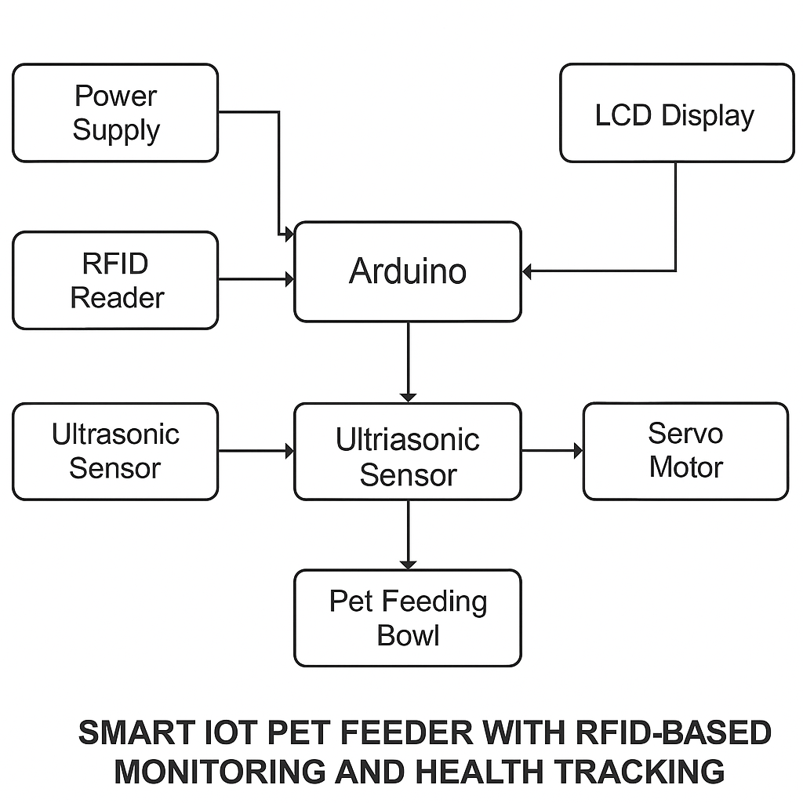preventing the car from starting and ensuring security.

**Figure 3.7: Block Diagram of IoT based Pet feeder**

## 3.8 Flow Chart

* Process flow to complete this paper successfully is included with input, process, and output of the system.
* Fingerprint is scanned to activate the ignition when an authorized user fingerprint is detected. Adding or deleting a fingerprint option is included in this project.
* In the case of adding or deleting a fingerprint, a master fingerprint will be set as an ID first.
* When the master fingerprint ID is authorized, then only the user can be added to the authorized list or deleted from it
* Followed by the Arduino which will process the received data from the fingerprint scanner.
* 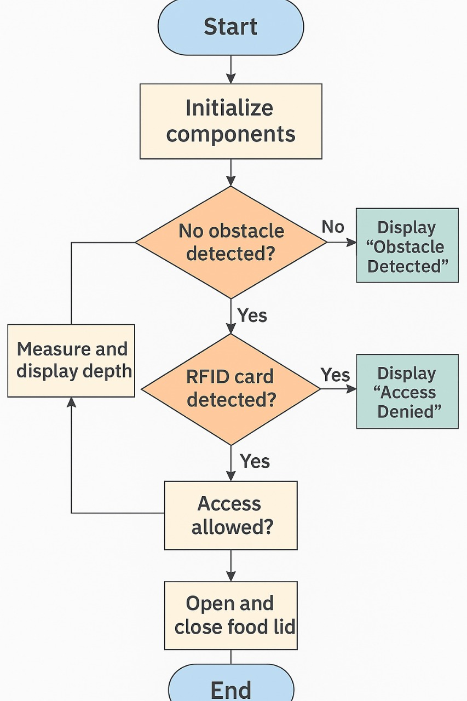The results will be displayed on the LCD. If fingerprints match, the vehicle’s ignition system will turn ON. If an unauthorized fingerprint is detected, the ignition will stay OFF.

**Figure 3.8: Flow Chart of Smart IoT Feeder with RFID based-monitoring and**

**health tracking**

# CHAPTER 4

# RESULTS AND DISCUSSION

The Smart IoT Pet Feeder with RFID-Based Monitoring and Health Tracking successfully automates pet feeding while monitoring health using an ultrasonic sensor. The RFID system ensures that only authorized pets receive food, improving the feeding accuracy. The ultrasonic sensor detects food depth, offering valuable insights into a pet’s eating habits. If the food depth remains high, indicating a lack of consumption, the system alerts the pet owner to potential health issues. The IoT platform enables remote monitoring, providing real-time data and notifications. This system is a reliable, non-invasive solution that enhances pet care, helping owners track feeding behavior and address health concerns promptly and efficiently.

* **Health Monitoring Setup**: Each pet is assigned an RFID tag, and an ultrasonic sensor is fixed on the pet feeding bowl to monitor food depth.
* **Feeding Process**: When the pet approaches the feeder, the RFID reader scans the pet’s tag to ensure it is authorized for feeding.
* **Health Check**: The ultrasonic sensor measures the depth of food in the bowl. A normal decrease in food depth indicates proper consumption.
* **Health Alerts**: If the food depth remains high, the system alerts the owner about potential health issues, such as stress or loss of appetite.
* **Data Logging**: The system logs the pet’s feeding behavior and health data for future analysis and tracking.
* **Remote Monitoring**: Pet owners can access real-time feeding and health data through an IoT platform or mobile app.
* **System Notifications**: The system sends alerts to the owner for any irregularities in feeding or health behavior.
* **User Interface**: A simple, user-friendly interface is provided to allow users to adjust feeding schedules, add or remove pets, and monitor health alerts.

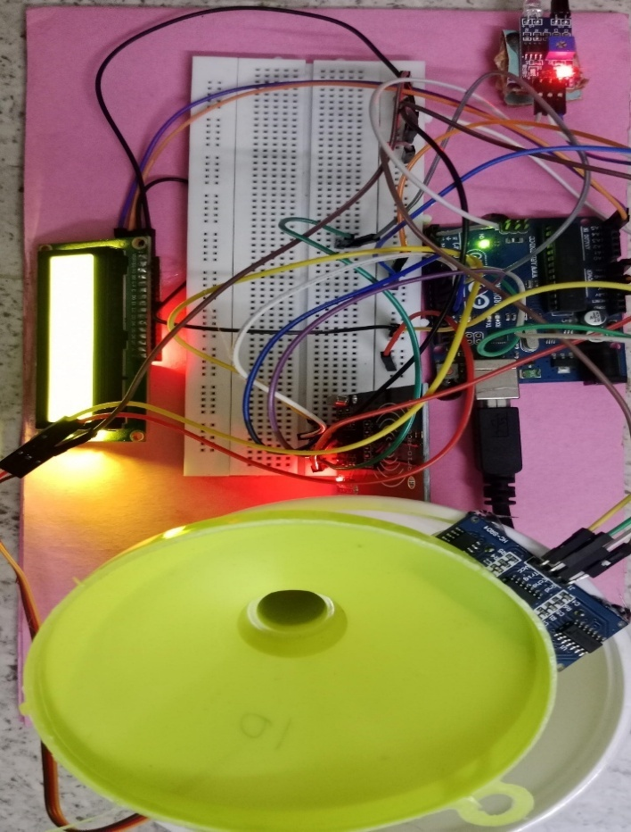

**Figure 4.1: Working Hardware Model**

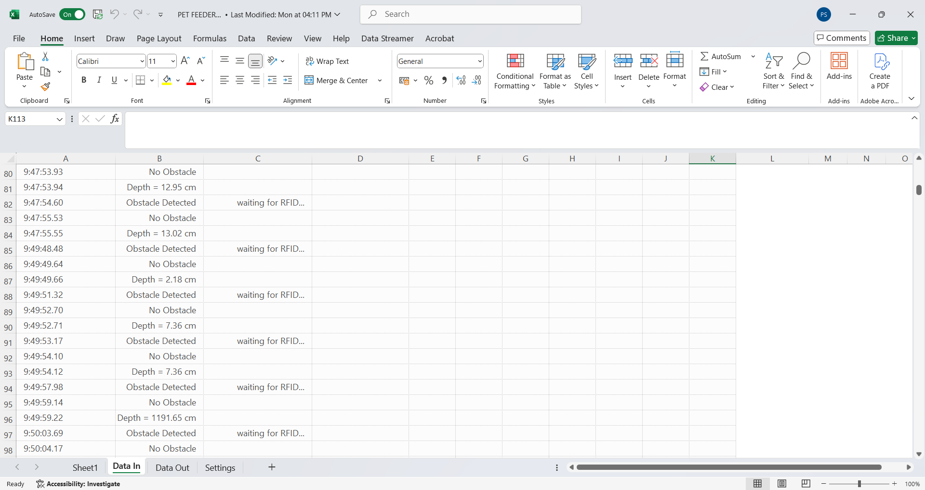

**Figure 4.2: Cloud based Data Sheet**

# CHAPTER 5

# CONCLUSION

The Smart IoT Pet Feeder with RFID-Based Monitoring and Health Tracking offers a comprehensive solution for automating pet care while ensuring the pet’s well-being through innovative technology. The system integrates RFID-based identification to personalize feeding routines for each pet, ensuring accurate and timely food distribution. Additionally, the ultrasonic sensor embedded in the feeding bowl serves a critical role in health monitoring by detecting the depth of food. This data is crucial for assessing the pet's health, as a high food depth may indicate reduced consumption, signaling potential health issues such as stress, illness, or loss of appetite.

Through real-time monitoring and IoT integration, pet owners can remotely track feeding behavior and health status, receiving notifications whenever abnormal consumption patterns are detected. This feature empowers pet owners to make timely interventions, ensuring better health outcomes for their pets. Furthermore, all feeding and health data is securely stored in the cloud, allowing pet owners to access and monitor their pet’s activity anytime and from anywhere, offering convenience and peace of mind. The system is designed to be user-friendly, efficient, and cost-effective, making it accessible to a wide range of pet owners. By combining RFID technology with health tracking capabilities and cloud integration, the project provides a reliable, non-invasive, and scalable solution for modern pet care, ensuring a healthier and more comfortable life for pets.

# REFERENCES

1. M. F. Mohd Yusof, N. H. A. Halim, M. A. M. Isa, M. A. M. Radzi, and M. A. Jailani,  
   "Automatic Pet Feeder System Using Arduino," International Journal of Advanced Trends in Computer Science and Engineering, Vol. 9, No. 2, pp. 2256–2261, 2020.
2. M.D.Ramirez, S.R.Mercado,and C.M.Fuertes,"IoT-BasedSmartPetFeeding System,”

International Journal of Computing and Technology, Vol. 7, No. 5, pp. 1–6, 2020.

1. N. A. Azmi, N. Zaini, and M. F. Miskon,"Development of Smart Pet Feeder Using Arduino and GSM Module," International Journal of Advanced Computer Science and Applications (IJACSA),Vol. 10, No. 6, pp. 345–349, 2019.
2. M. L. Badulescu, F. Dragan, and A. Dragota,  
   "Design and Implementation of a Smart Pet Feeder with IoT Features,"Procedia Manufacturing,Vol. 46, pp. 303–309, 2020.
3. K. C. Prasad and B. S. Reddy,  
   "Automated Pet Feeder with IoT Connectivity,"International Research Journal of Engineering and Technology (IRJET),Vol. 6, No. 6, pp. 3425–3429, 2019.
4. P. V. Dhamal and S. S. Khandagale,"Automated Smart Pet Feeder Using Arduino Uno,"  
   International Journal of Scientific Research and Engineering Development (IJSRED),  
   Vol. 2, No. 2, pp. 104–110, 2019.1